Project Lifecycle Template (5-Phase General Model)

In this Project Lifecycle Template we describe the key phases by activities to be undertaken by project manager in collaboration with the senior stakeholders and experts. You can use this template as additional guidelines for planning your activity-based project.

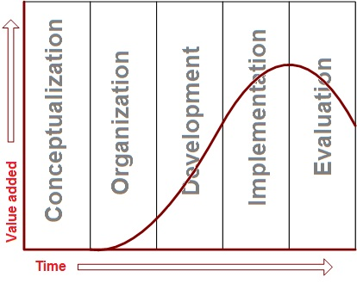

Phase 1. Conceptualization. Purpose: define the project and prepare it for approval.
- Define and explain the project need (what’s required?) and purpose (why is this required?)
- State the problem to be solved by the project
- Identify the project solution
- List the benefits to be gained upon successful project completion
- Develop the project concept
- Perform a feasibility analysis to prove the project is technically feasible and economically viable
- Identify how the project relates to other dependent/child projects running in parallel
- Set priority to the project
- Explain business background and strategic content
- Determine ethical considerations
- Define options (alternatives) to proposed solution
- Perform an analysis to evaluate the options and prove the solution is reasonable to choose
- Make recommendations regarding project launch
- Develop a project proposal document and submit it for review to the sponsor

Phase 2. Organization. Purpose: to define and approve the organizational structure of the project.
- Assign the Project Manager
- Acquire and assemble the project team
- Perform stakeholder analysis to identify people affected by or interested in the project, analyze their needs, and decide on involvement level (how the stakeholders are allowed to influence project decision making)
- Determine broad scope, including:
  - Constraints & assumptions
  - Boundaries (inclusions & exclusions)
  - Deliverables
  - Requirement
- Establish project objectives and goals
- Identify the governance structure including
  - Roles and responsibilities
  - Functions
  - Delegations
- Establish preliminary timeframes for project activities
- Perform a preliminary cost assessment to develop project cost estimate
- Undertake a preliminary risk assessment to identify expected risks and threats affecting the project
- Develop a project organization document and submit it for review and approval to the senior management

Phase 3. Development. Purpose: to develop an implementation plan and ensure increased commitment of resources
- Define the scope through decomposing project work into smaller action items, such as tasks and activities
- Develop the project schedule based in activity duration estimates
- Create the risk management plan based on the risk assessment
- Identify types and quantity of resources (labor, funds, technology, inventories, land, etc.) required for the project
- Develop a budget sheet based on cost projections
- Create the communications plan
- Determine the controls including tracking procedures, reporting rules, change management process, issue/risk logging
- Design the quality management plan
- Develop the procurement plan
- Write the handover plan that explains deliverable acceptance criteria and how to hand over the product to the customer
- Prepare the project plan that is based on the data of the subsidiary plan.

Phase 4. Implementation. Purpose: to convert the approved project plan into reality and to achieve the project objectives.
- Start executing the project plan
- Monitor and control changes made to the key parameters such as:
  - Scope
  - Time (schedule)
  - Cost (budget)
  - Quality
  - Issues/Risks
  - Handover Plan
- Manage stakeholder expectations and communications
- Report performance through status reports and meetings
- Manage variance requests
- Confirm the planned results are produced

Phase 5. Evaluation. Purpose: to integrate the produced outcome into the operational environment
- Perform administrative closeout of the project and its activities
- Communicate with the customer to agree of the deliverables acceptance
- Implement the handover plan (transferring the deliverables to the customer)
- Develop a handover report (whether the deliverables have successfully reached the customer)
- Conduct a post-project meeting to summarize the work and identify lessons-learned
- Undertake a business-benefits review to identify whether the expected benefits have been gained upon project completion
- Announce project end and celebrate
- Develop a project completion report and submit for approval to the senior management team (e.g. Steering Committee)
- Archive project documentation
- Dismiss personnel.

